EXPERIMENT NO: 23
Implementation of Family Tree Using Prolog.
AIM:
To write and execute a Prolog program to represent family relationships and identify father, mother, siblings and grandparents using facts and rules.
PROCEDURE:
- Open SWISH Prolog software.
- Enter the Prolog program in the editor.
- Define male and female members as facts.
- Define parent relationships between family members.
- Create rules to identify father, mother, siblings and grandparents.
- Click the Run button to load the program.
- Enter the required query in the Query box.
- Click Run to execute the program.
- Observe the family relationships in the output.
PROGRAM:
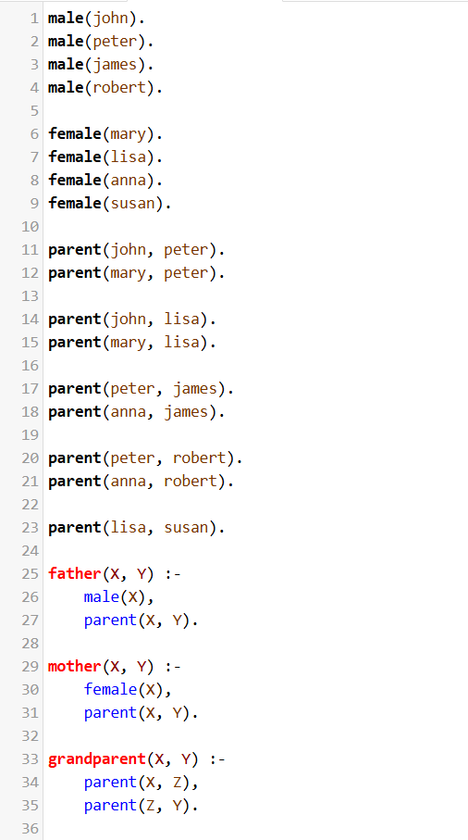

OUTPUT
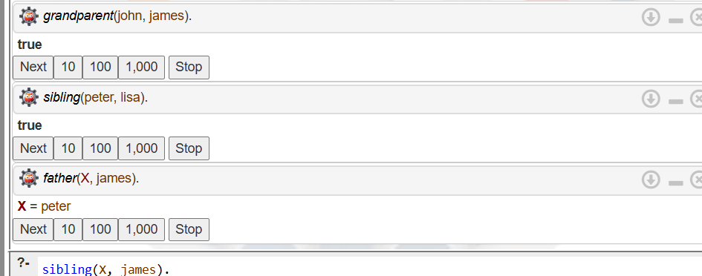

RESULT:
Thus, the Prolog program to implement a family tree and identify different family relationships using facts and rules was successfully executed.

